**Anisothermal Ternary Generator**

**User Guide**

Version 1.0 – S.F. Yeates – 20/09/2025

This User Guide explains the operation and set-up of the Anisothermal Ternary Generator (ATG) and includes a demonstration dataset and figure link, which are produced using the ALDEMO Thermo-Calc database.

All figures and CALPHAD work have been done using the following software versions:

* Thermo-Calc 2025a
* ALDEMO Database
* Anisothermal Ternary Generator V1.3
* Anisothermal Plotter V1.31

Figure Extracted images from the Al-Cu-Si anisothermal ternary

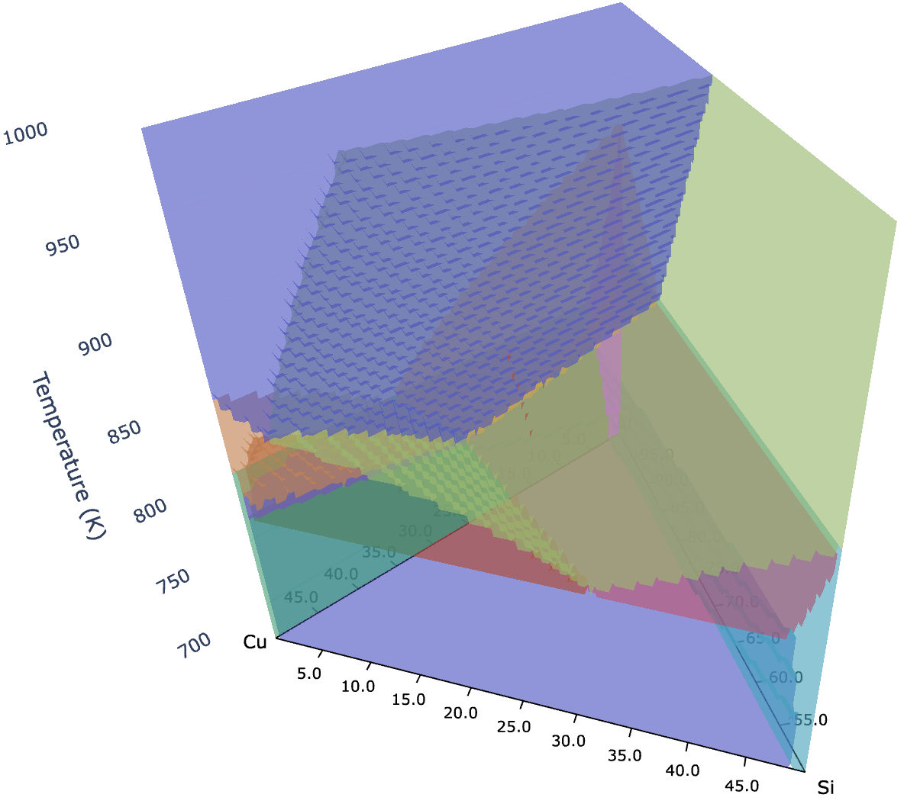

# User Guide

## Workflow

The GitHub contains two python scripts: Anisothermal Ternary Generator and Anisothermal Ternary Plotter. The Anisothermal Ternary Generator should be used first to produce an anisothermal dataset, which the Anisothermal Ternary Plotter then presents as an html figure. In theory it would be possible to use the Anisothermal Ternary Plotter on a custom dataset (E.g. a fictional educational model), but care should be taken to ensure compatibility of the custom .csv.

The Anisothermal Ternary Generator uses TC_Python to produce a .csv file comprised of metadata rows, and then a series of rows containing the thermocompositional point definition (T, Elemental Composition) and the predicted stable phases, phase fractions and phase compositions for that thermocompositional point. It does this using the Single Point Equilibrium calculation module within TC_Python. Each isothermal ‘layer’ is grouped together to minimise restarting the TC_Python calculation engine. Concurrent Futures is used to allow multiple isothermals to be run at once, accelerating the calculation process.

The user should define the alloy system and thermal range they are interested in via the Python Variable inputs (clarified in the following section). Due to the computational time for a standard desktop or laptop to run high resolution systems, it is recommended that a user follows the workflow shown in figure 2.

Figure - Recommended workflow to down select thermocompositional range.

Once the ATG has been set up and run, the Anisothermal Ternary Plotter can be used to produce the final dataset. Care should be taken when selecting high resolution step size. The size of the figure dramatically increases based on resolution, with 0.1wt% figures being too large to open reliably in standard browsers (Chrome, Edge, Firefox).

## Anisothermal Ternary Generator

### Set Up

This guide does not cover the set up and installation of TC-Python. For guidance on this, please refer to Thermo-Calc’s TC-Python User Guide.

In addition to TC-Python, a user will need a suitable IDE and the following Python libraries installed:

1. Pandas – Used to manage data structure
2. Numpy – Used to manage data computation
3. Time – Used to track run time of scripts
4. Concurrent Futures – Used to parallelise tasks

The Thermo-Calc license information must be set up correctly. By default, the licence set-up follows the macOS requirements. For further guidance on adapting this for your set-up, please refer to the TC-Python User Guide or Thermo-Calc support ([support@thermocalc.com](mailto:support@thermocalc.com)).

### Inputs

Table - Python Input Variables that a user must edit prior to running the script.

|  |  |  |
| --- | --- | --- |
| Python Variable | Purpose | Type |
| Database | Define ThermoCalc Database | String |
| GeneratePhaseFraction | Toggle between Phase Fraction Data or not | Boolean (True = Generate) |
| Tmin | Maximum Temperature | Integer |
| Tmax | Minimum Temperature | Integer |
| Tres | Temperature Step | Integer |
| Pressure | Isobaric Pressure | Integer |
| MassFraction | Toggle between Mass or Atomic Fraction | Boolean (True = Mass Fraction) |
| A1Es | Element(s) along Axis One | List of strings |
| A1EComps | Relative stoichiometry | List of floats |
| A2Es | Element(s) along Axis Two | List of strings |
| A2EComps | Relative stoichiometry | List of floats |
| A2max | Maximum fraction | Float |
| A2res |  | Float |
| A3Es | Element(s) along Axis Three | List of strings |
| A3EComps | Relative stoichiometry | List of floats |
| A3max | Maximum fraction of Axis Three | Float |
| A3res |  | Float |

### Outputs

The ATG will automatically save the anisothermal dataset as a .csv automatically named based on the input parameters. The output filename will be

## Anisothermal Plotter

The Anisothermal Ternary Plotter (ATP) is set up to allow a user to not edit it. The script should be run, which will initially open a dialogue window to allow the user to select a .csv that they wish to plot. The script will then open the .html figure in the user’s browser, and save the figure to the working directory of the script. There is no need for the user to edit any element of the ATP code.

*End of User Guide – See below example of application*

## Example - Al-Cu-Si Ternary System

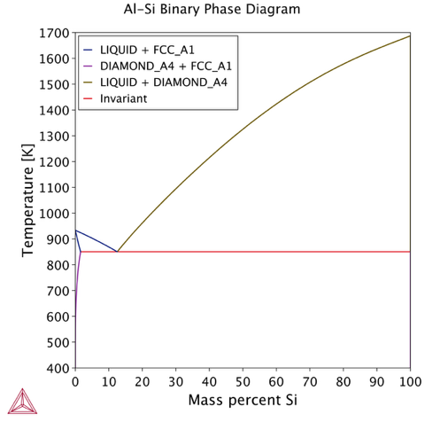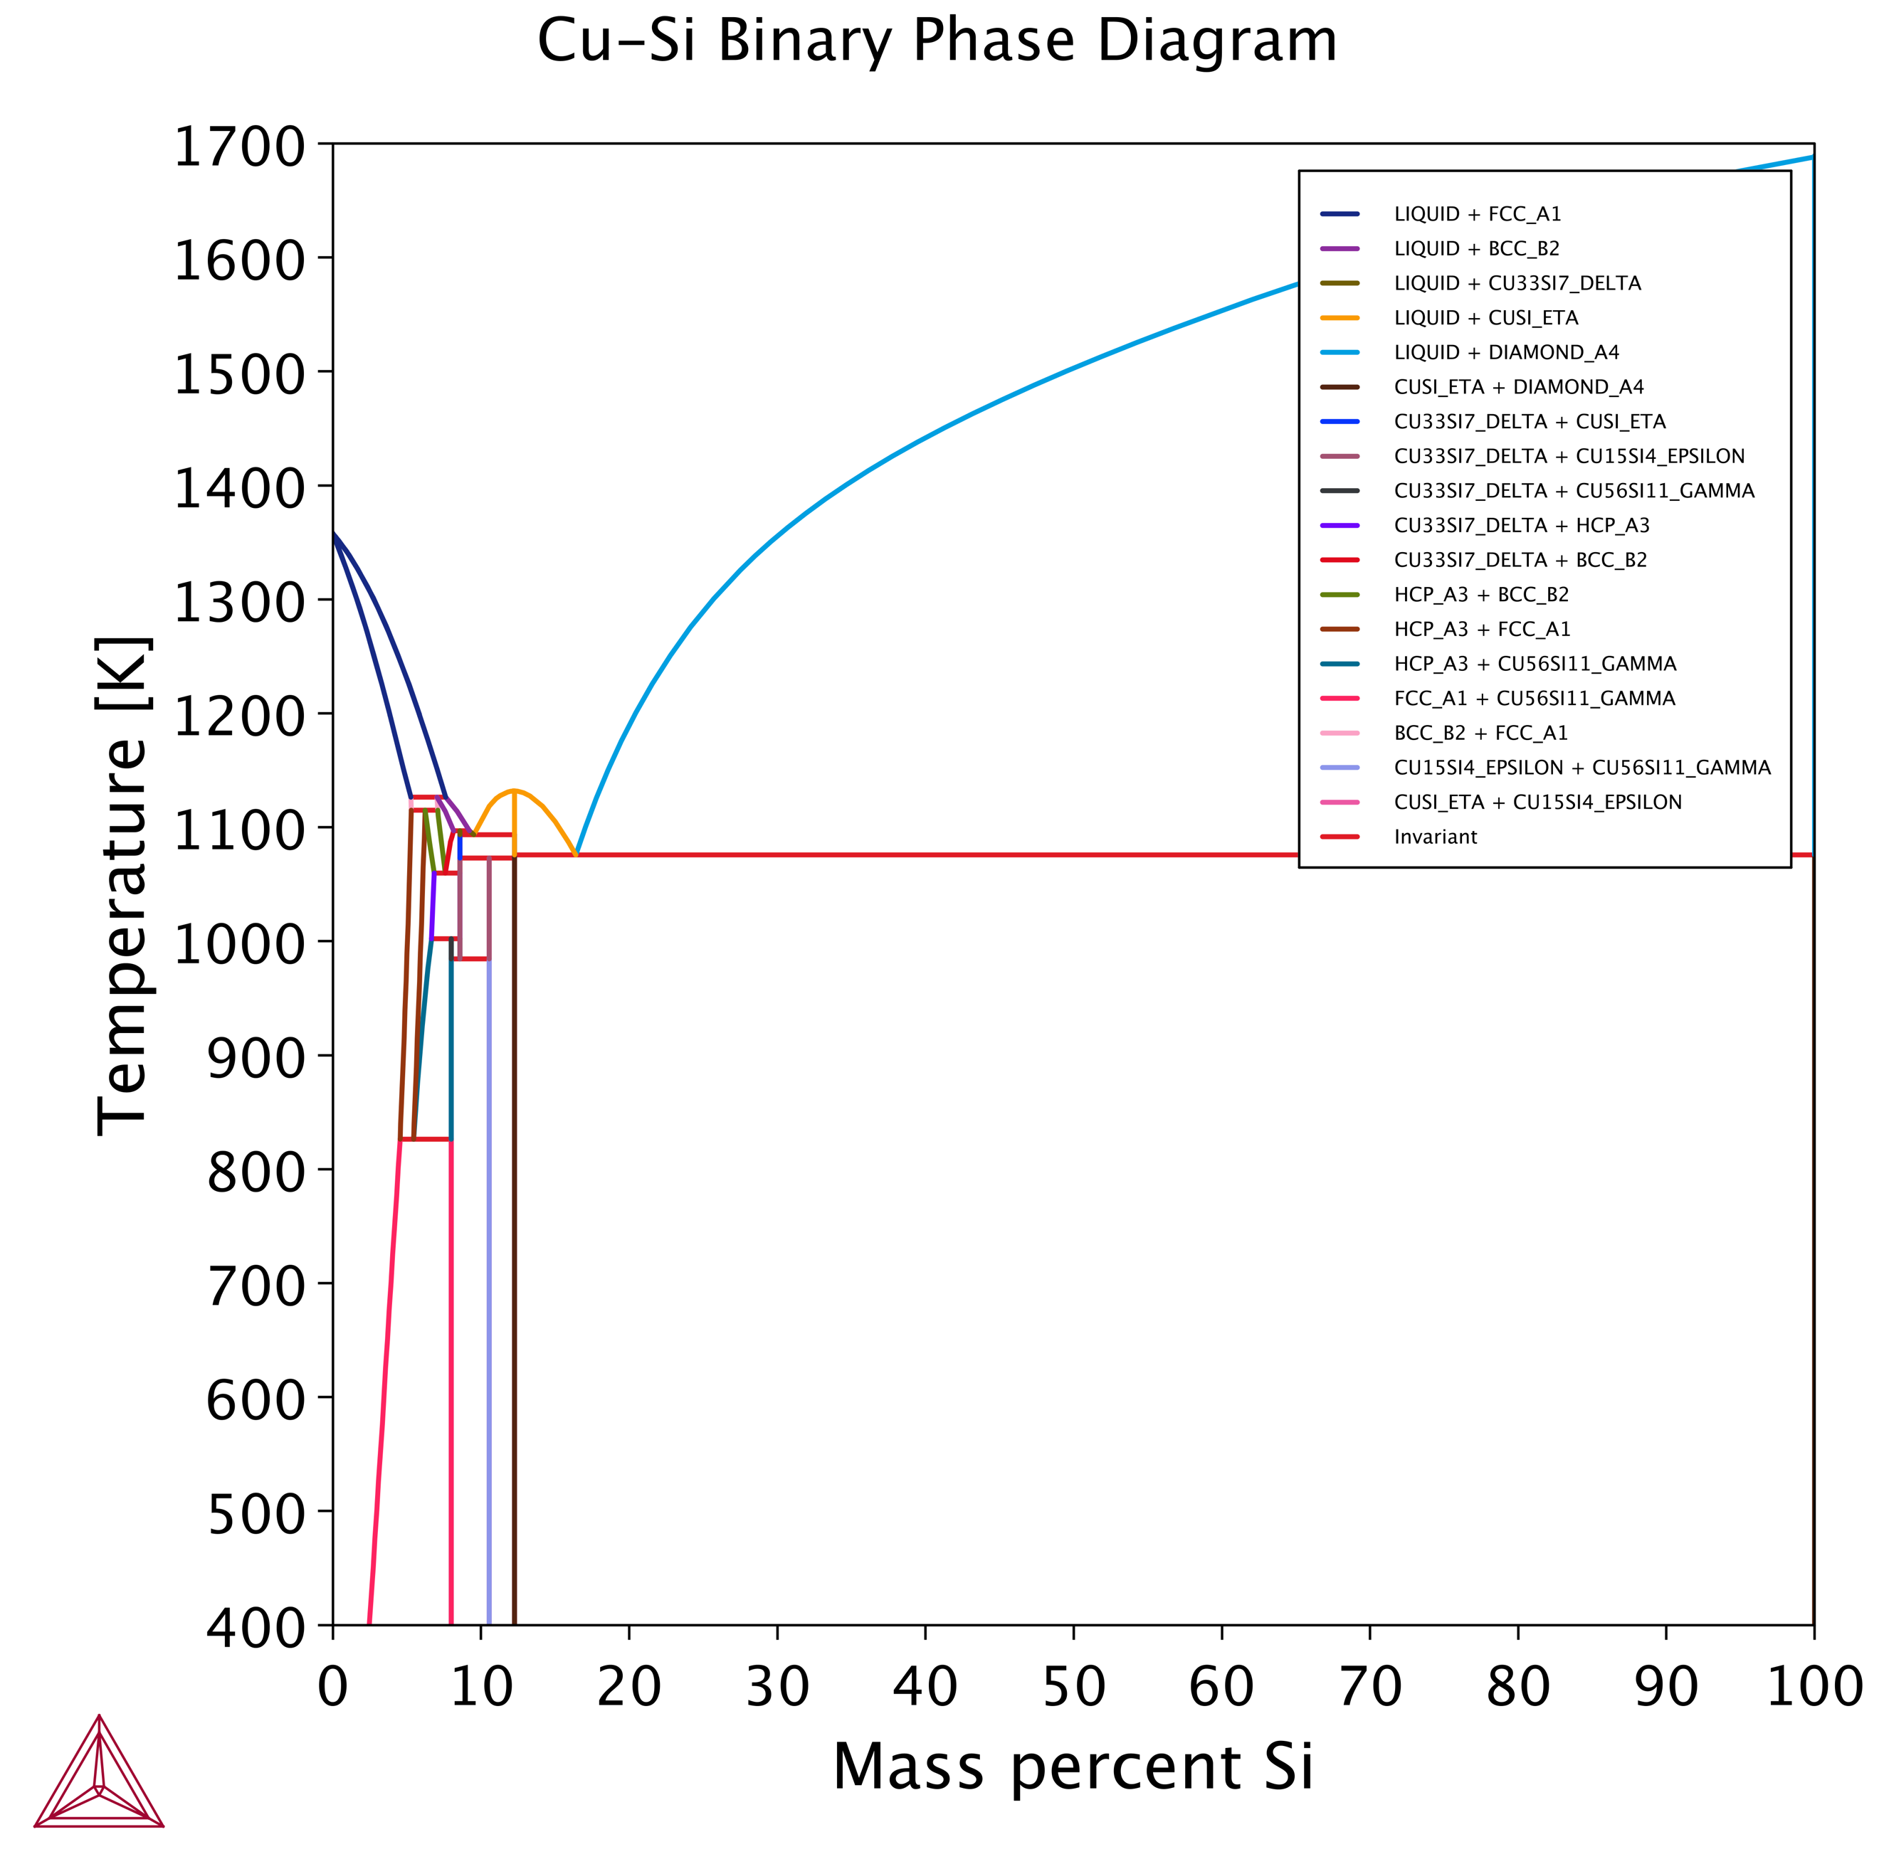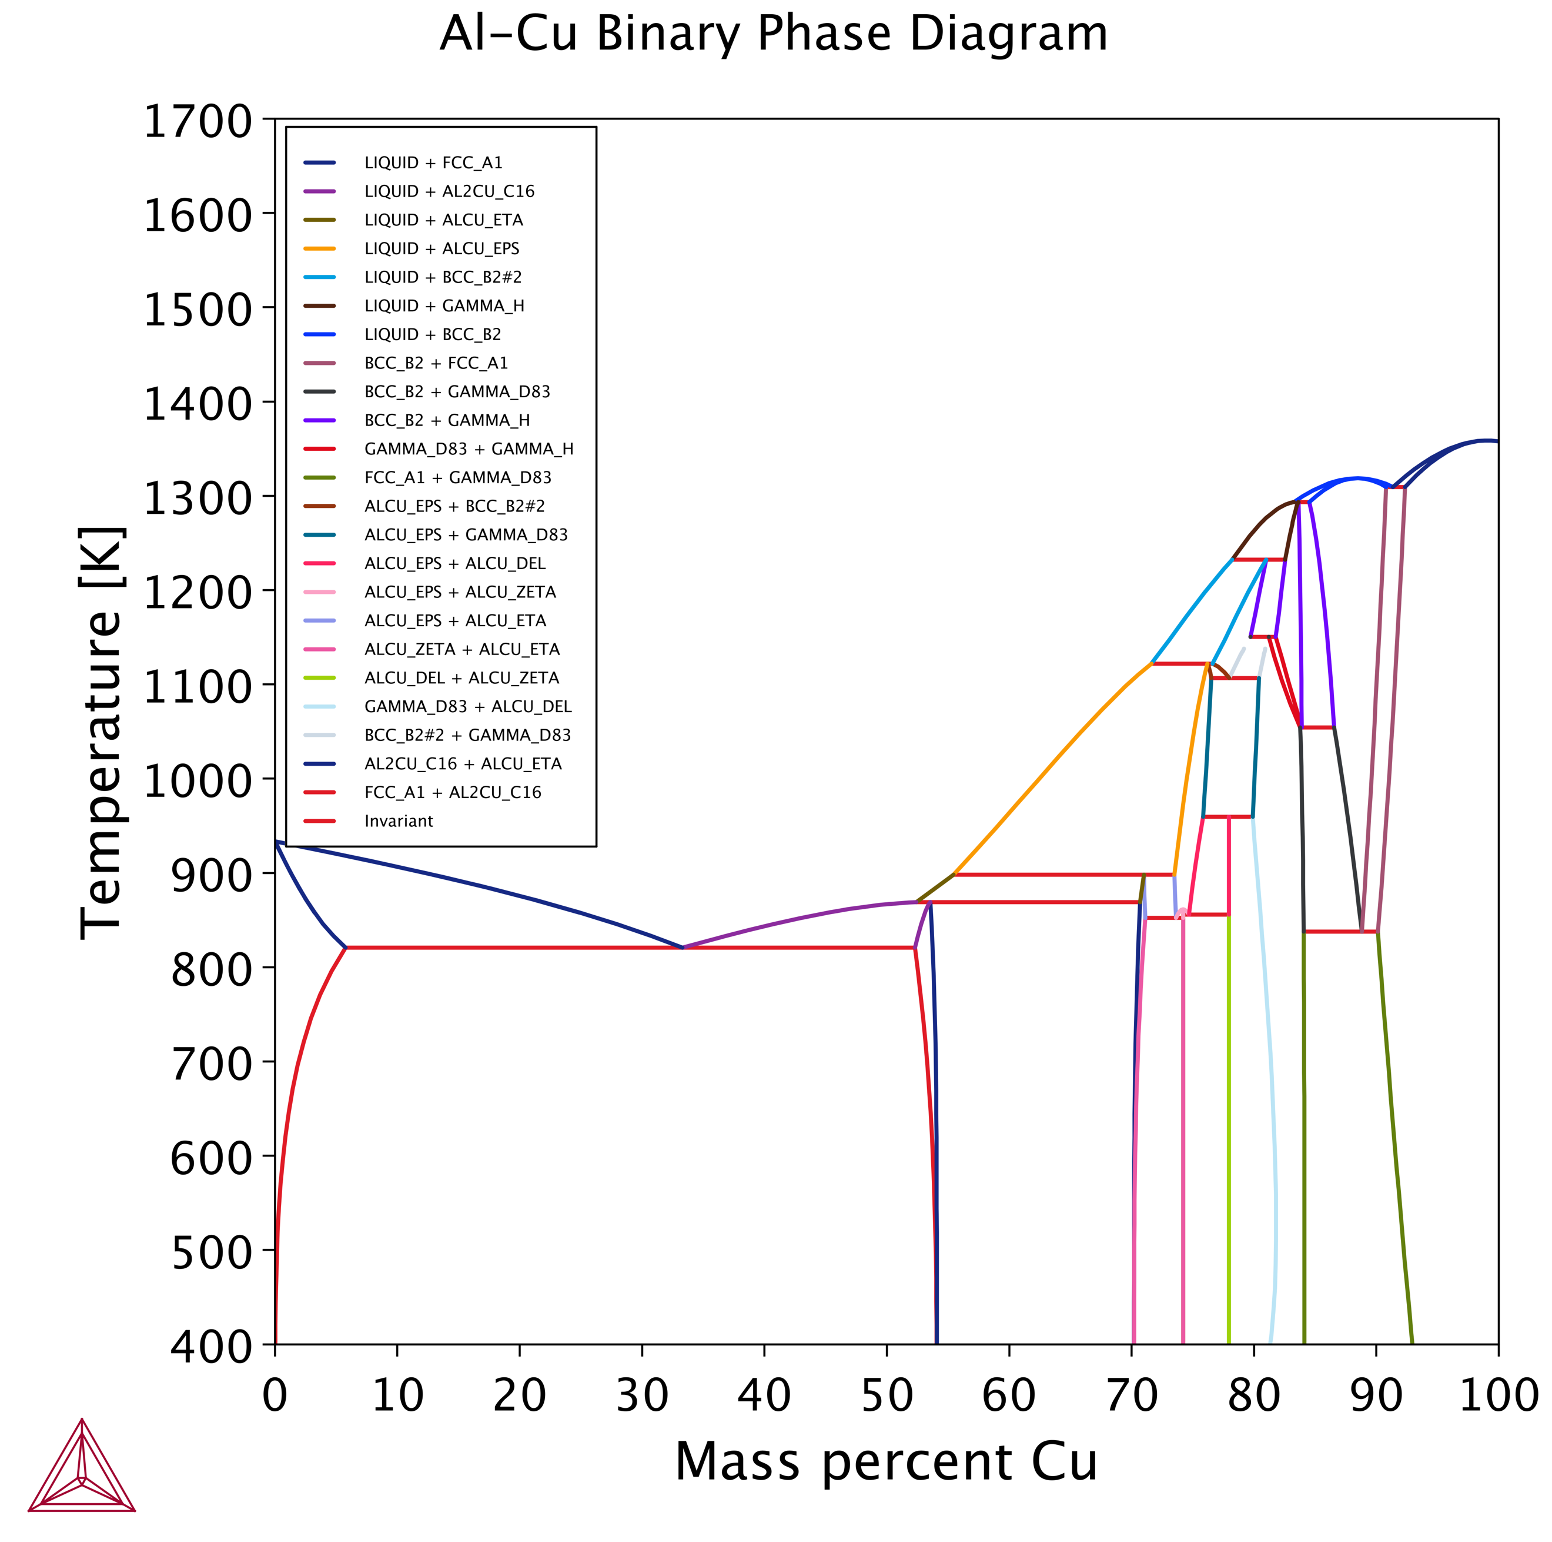

Figure – Component Binary Phase Diagrams of the Al-Cu-Si Ternary System

As this is a User Guide, the Al-Cu-Si system has been selected as all three elements exist in a Thermo-Calc Demo database and all three binaries contain interesting metallurgical features. Figure 1 shows the three relevant binary systems predicted in Thermo-Calc via the graphic user interface method (GUI).

All three binaries also contain a eutectic composition, which suggests that the ternary is likely to have eutectic valleys and a ternary eutectic composition. This makes it an ideal system to explore anisothermally. There is also complex phase behaviour at high Cu concentrations. As this is undesirable, this system can also demonstrate the use of partial ternary phase diagrams.

### Input

Table - Required inputs to produce a 'high' resolution anisothermal ternary diagram for the Al-Cu-Si system, capped by Cu<50wt%, Si<50wt%.

|  |  |  |
| --- | --- | --- |
| Python Variable | Input | Notes |
| Database | “ALDEMO” | Al Demo Database |
| GeneratePhaseFraction | True | Code will generate Phase Fraction information |
| Tmin | 700 | Sets min. temperature to 700K |
| Tmax | 1000 | Set max. temperature to 1000K |
| Tres | 5 | 5K Steps – High temperature resolution |
| Pressure | 100000 | 100kPa – Standard Pressure |
| MassFraction | True | Compositions in wt% |
| A1Es | [“Al”] | Sets the elements in axis one to Al only |
| A1EComps | [1.00] | Sets the relative ratio of Al to 100% |
| A2Es | [“Cu”] | Sets the elements in axis two to Cu only |
| A2EComps | [1.00] | Sets the relative ratio of Cu to 100% |
| A2max | 50.0 | Sets the max. value of Axis Two to 50% (MassFraction controls at% vs wt%) |
| A2res | 0.5 | Sets the step size of axis two to 0.5% |
| A3Es | [“Si”] | Sets the elements in axis three to Si only |
| A3EComps | [1.00] | Sets the relative ratio of Si to 100% |
| A3max | 50.0 | Sets the max. value of Axis Three to 50% (MassFraction controls at% vs wt%) |
| A3res | 0.5 | Sets the step size of axis three to 0.5% |

### Output

Figure - Anisothermal Ternary Phase Diagram of Al-Cu-Si (Cu & Si capped at 50wt%)

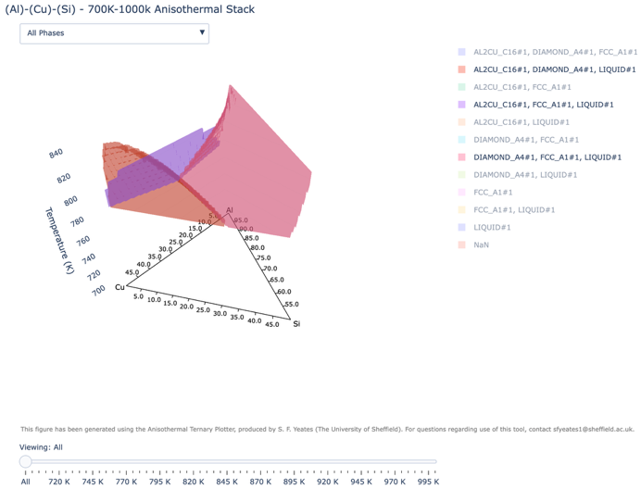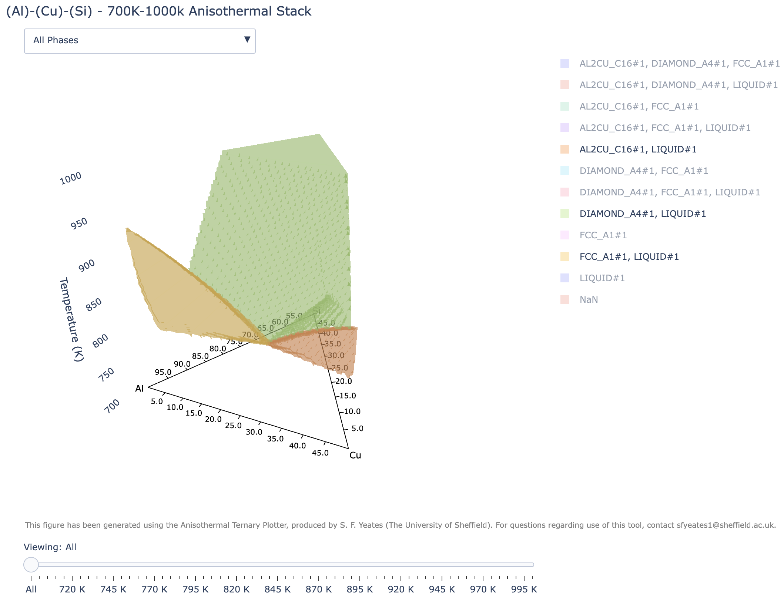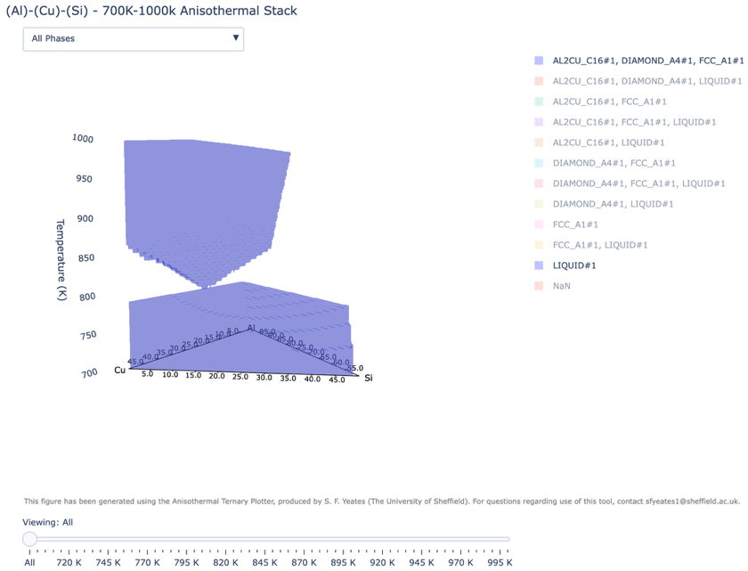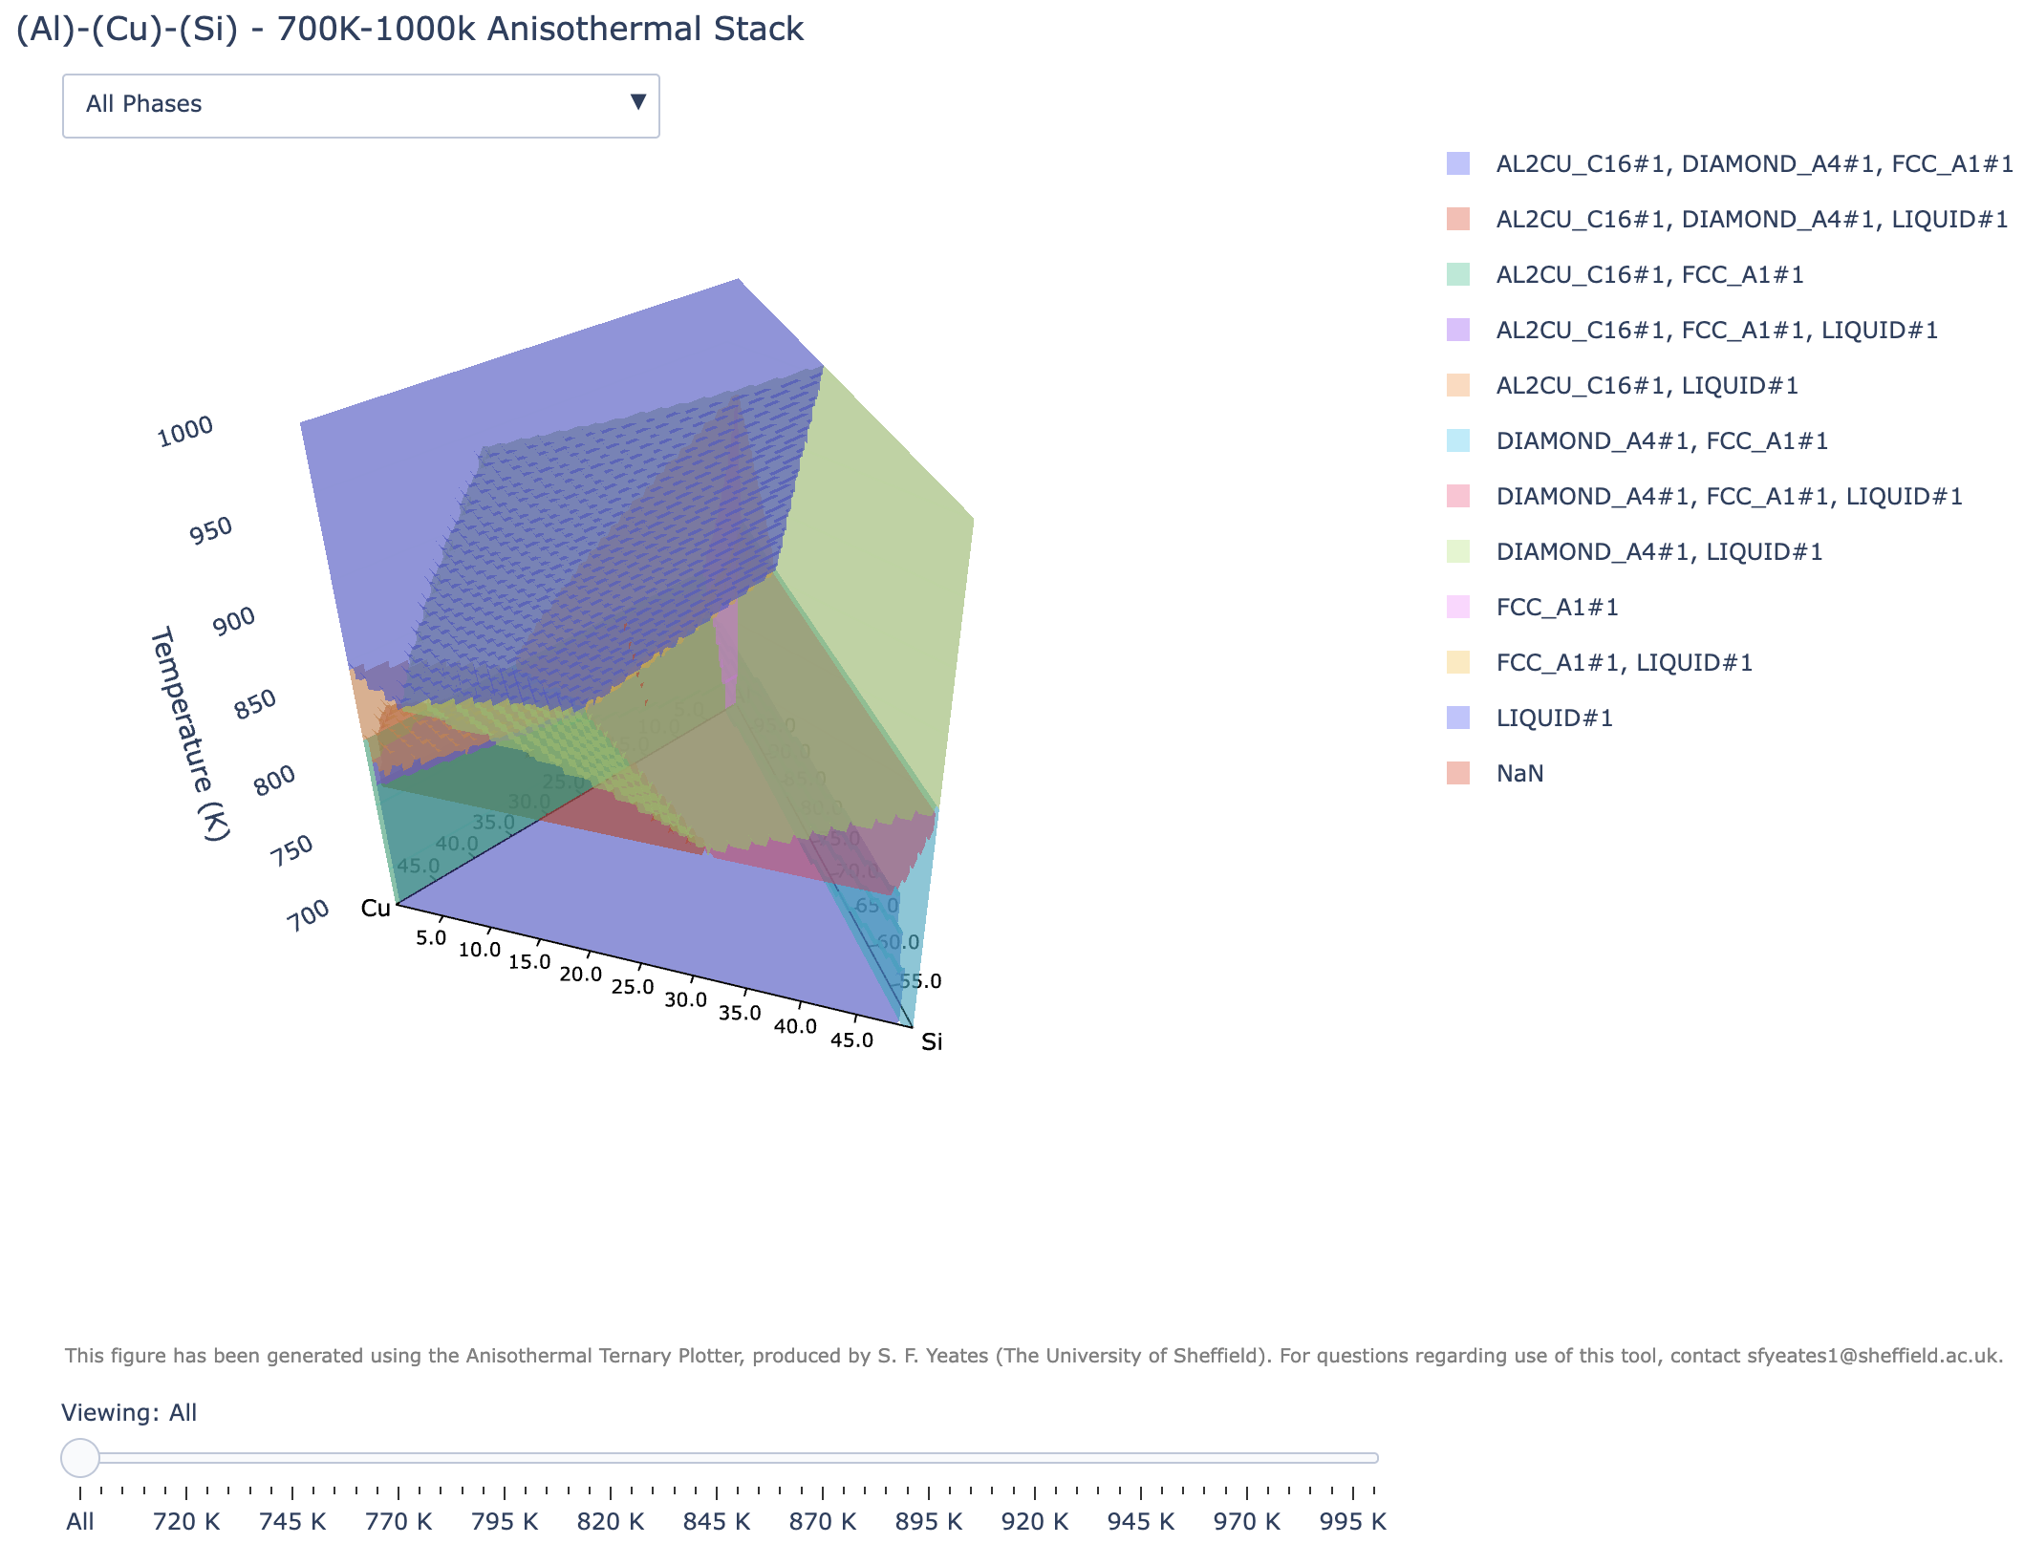

**A**

**B**

**C**

**D**

**E**

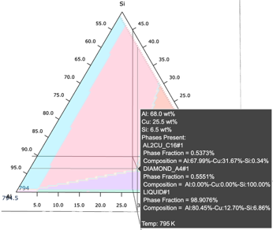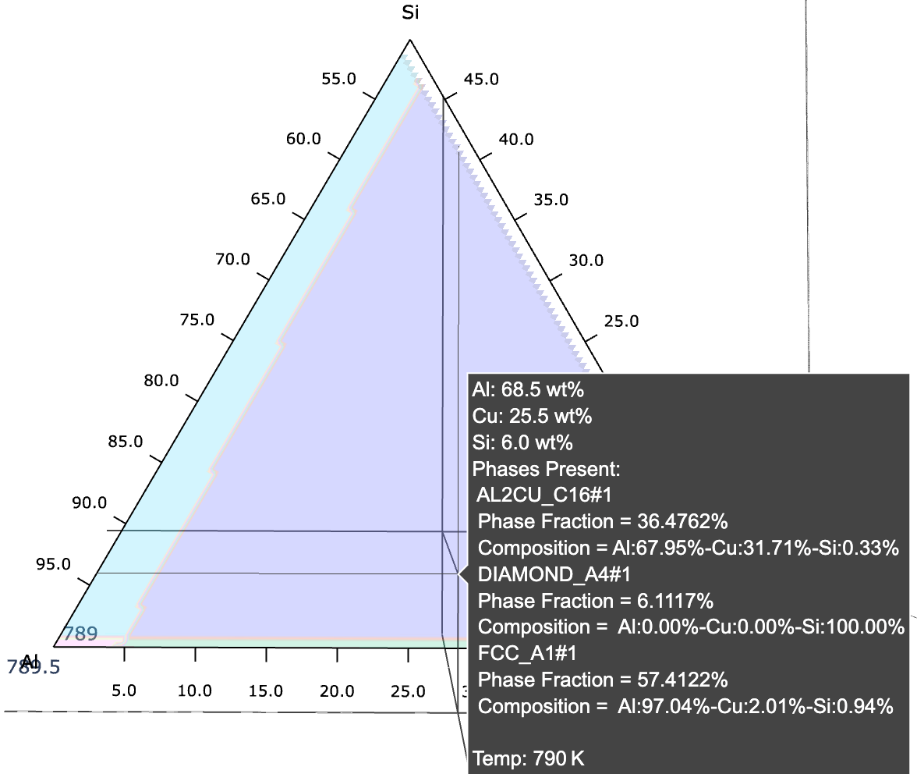

Figure 4 shows a selection of images taken from the outputted .html, produced by using the ATG and ATP with the inputs given in table 2. Figure 4A shows the overall figure, from which it is possible to visually identify the binary system phase diagrams shown on the 3 sides of the triangular prism.

As predicted based on the phase diagrams for the three binaries, the ternary system has three eutectic valleys which meet to form a ternary eutectic point. At this point the following ternary eutectic transformation is predicted:

*Liquid -> FCC_A1+Diamond_A4+Al2Cu_C16*

This transformation is highlighted with Figure 4A, with the Liquid and tri-solid-phase regions isolated. Figure 4C shows how the isothermal slider can be used to identify the exact composition and temperature this point occurs at (790 K, Al69Cu25.5Si6.5). Figure 4D and E show the three Liquid+Solid and Liquid+Dual Solid phase regions. Cooling through any of these areas is likely to produce complex microstructures.

It would be the user’s decision about how to further interrogate the diagram, and when to move to alternative tools. Depending on the targeted microstructure, phase fraction diagrams of the ternary eutectic composition may be valuable, or further pseudo-binary exploration of the eutectic valleys.

Due to a file size limit on standard Git repositories, the high resolution .html cannot be uploaded. To allow the user to practice exploring the diagram figures produced a lower resolution diagram has been produced and uploaded to the Git repository. If a user would like access to the higher resolution figure, they should contact sfyeates1@sheffield.ac.uk.